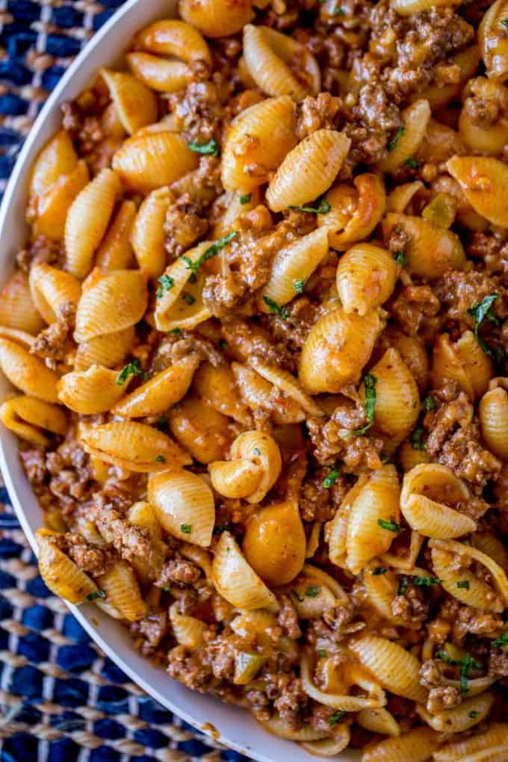
Cheesy Taco Pasta
Prep Time 5 minutes Cook Time 20 minutes
4 Servings

Ingredients
½ lb. medium shells pasta
1 lb. ground beef
½ cup minced onions
4 Tbsp taco seasoning (or 1 packet)
¾ cup water
1 cup jarred salsa
1 cup shredded cheddar cheese or more to taste

Directions for Prep
- Cook the pasta according to the directions on the box and drain.
- Add the ground beef to the pan and cook for 4 to 5 minutes or until meat is brown and cooked through.
- Add the onion and cook for an additional 3 to 4 minutes or until onion is translucent.
- Drain the fat.
- Add the taco seasoning and ¾ cup of water, stir and cook until water is gone.
- Stir in salsa, cheese and pasta.
- Serve immediately, preferably with crunchy tortilla chips and sour cream (optional) on top.

